# Machine Learning Week 5 Progress Report

Group Members:

Aarya Parekh AU2120075

Diya Patel AU2120193

Kavyan Savani AU2120231

Vatsal Shah AU2040082

## Progress Abstract

Throughout this week's time, we implemented a bounding box that is described by four coordinates along a particular road, and then we extract a histogram from this area. After that, we used Jenks clustering techniques to identify lane boundaries. One significant issue that arose concerned road layouts that accommodated three regular lanes in addition to an additional lane that was occasionally used by taxis. The difficulty we encountered in classifying this extra lane led to our decision to increase the bounding box dimensions in order to cover a larger area and make lane detection easier. As such, our methodology results in the identification of three lanes when we exclude taxis and four lanes when taxis are included. Thereby navigating the intricacies of lane segmentation in multifaceted road environments.

## Progress Timeline

### 01–04-24

Today we discussed how to approach the bounding box detection. In the end, we decided to have two different types of bounding boxes, one that was parallel to x-axis and y-axis, that had a rotation of 0 or pi/2 radians. The other can be any arbitrarily rotated box with a direction specified. Based on that the orthogonal distance from the edge of the road is calculated.

### 04–04-24

We implemented the bounding box as discussed in the previous meeting and also extracted a histogram on the bounding boxes. Preliminary results are shown and discussed below. The results are taken from different roads at different times and for different periods of time.

## Preliminary Results

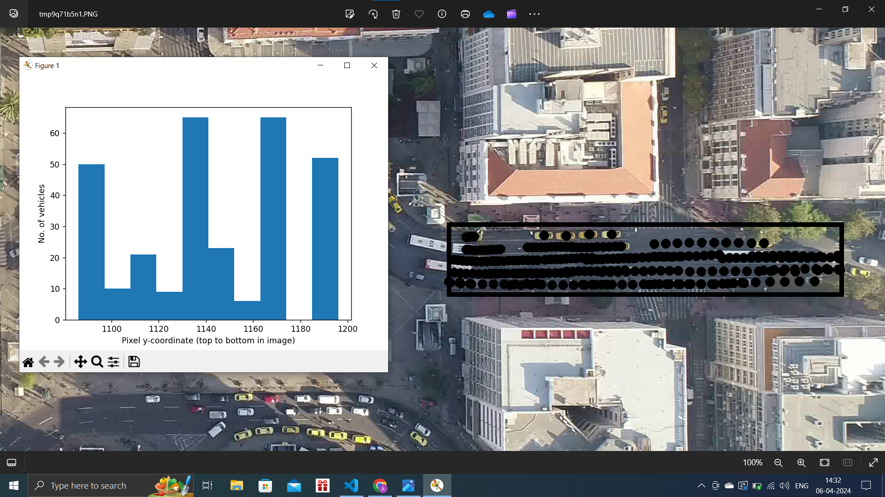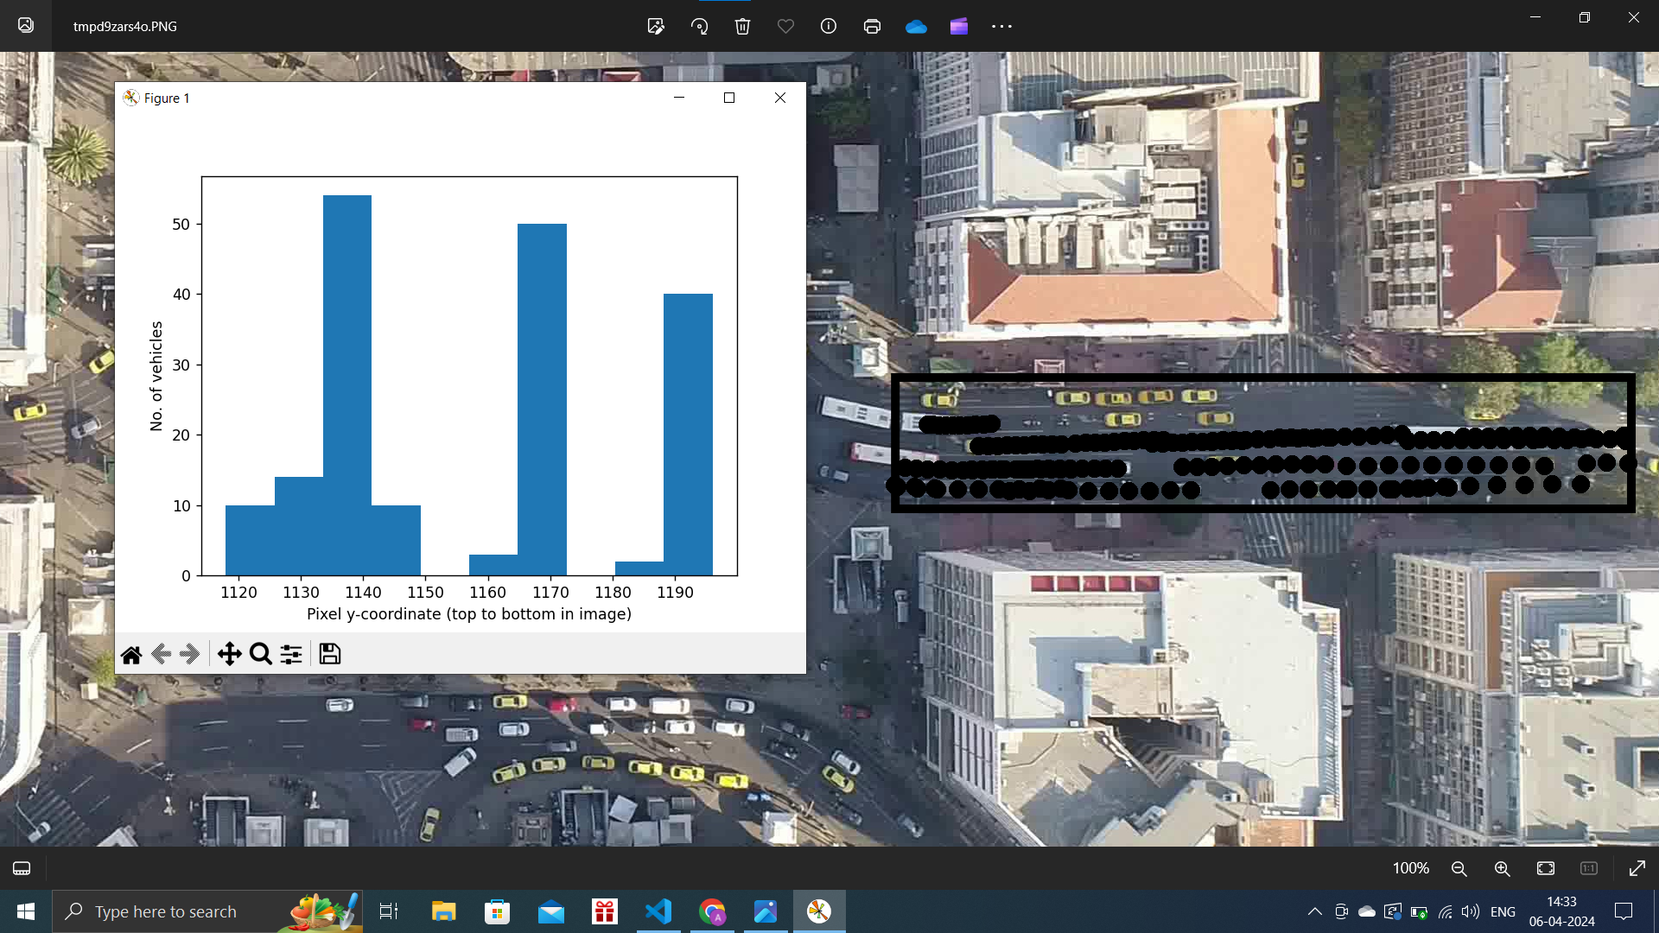

| Fig. 1. SubLoc 1 Start Time 0 Duration 10 Frames Filtered Motorcycle | Fig. 2. SubLoc 1 Start Time 0 Duration 10 Frames Filtered Motorcycle, Taxi |
| --- | --- |

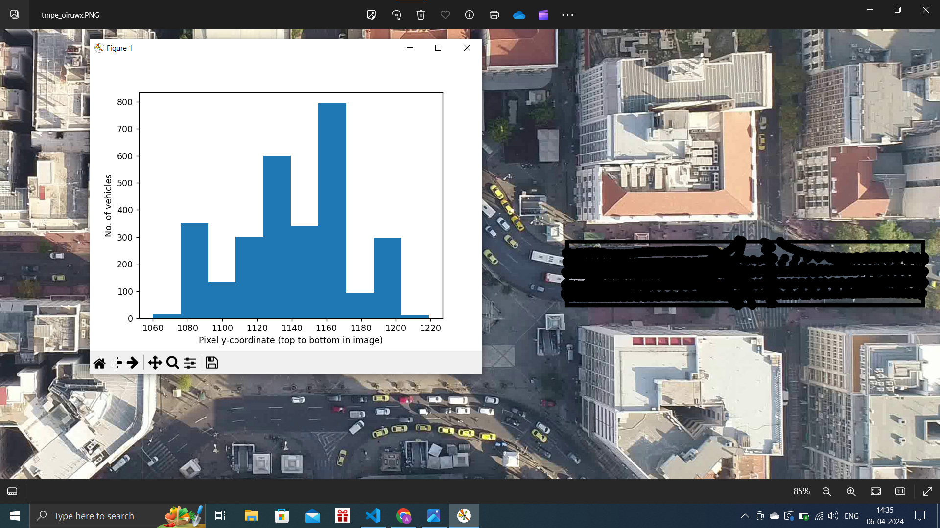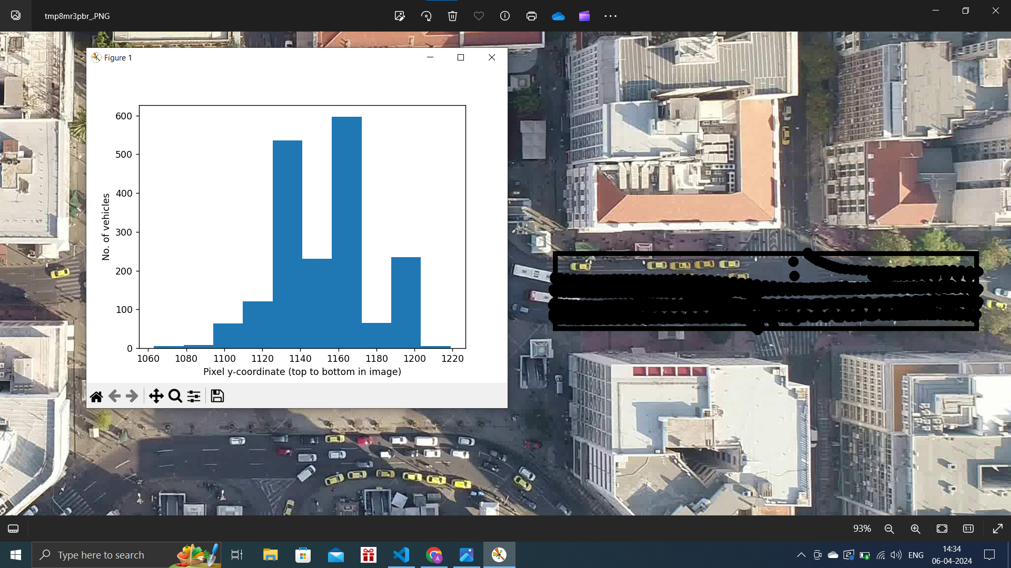

| Fig. 3. SubLoc 1 Start Time 0 Duration 100 Frames Filtered Motorcycle | Fig. 4. SubLoc 1 Start Time 0 Duration 100 Frames Filtered Motorcycle, Taxi |
| --- | --- |

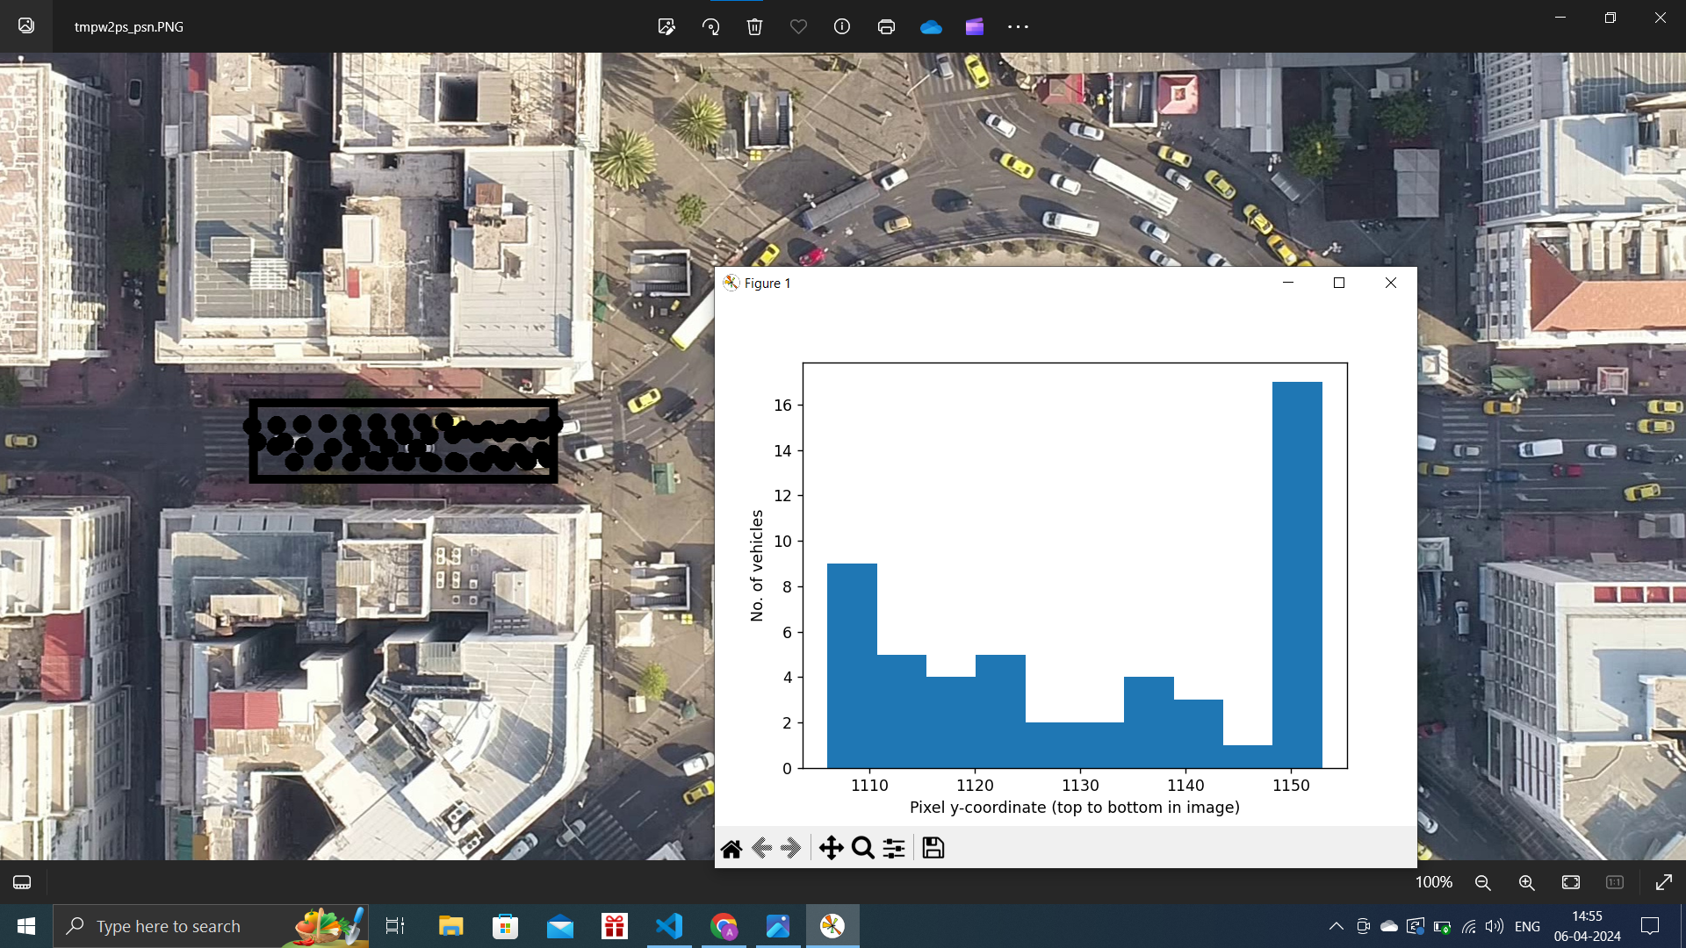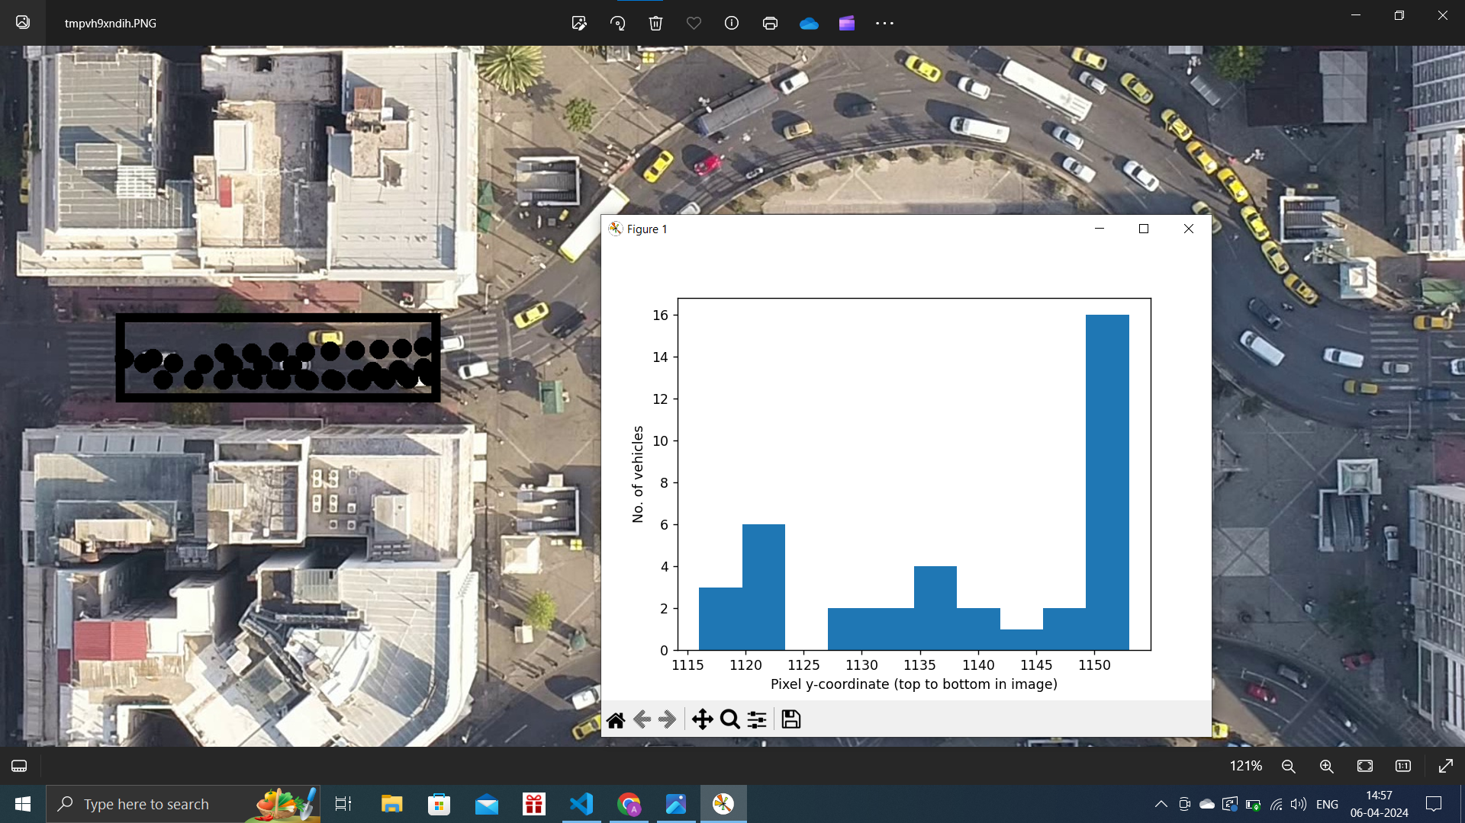

| Fig. 5. SubLoc 2 Start Time 106 Duration 10 Frames Filtered Motorcycle | Fig. 6. SubLoc 2 Start Time 106 Duration 10 Frames Filtered Motorcycle, Taxi |
| --- | --- |

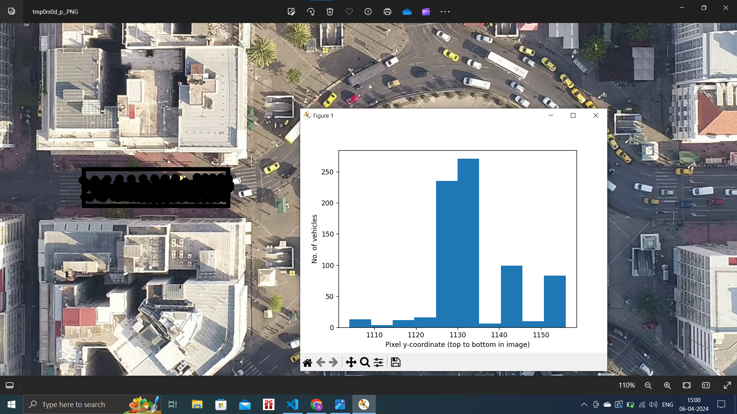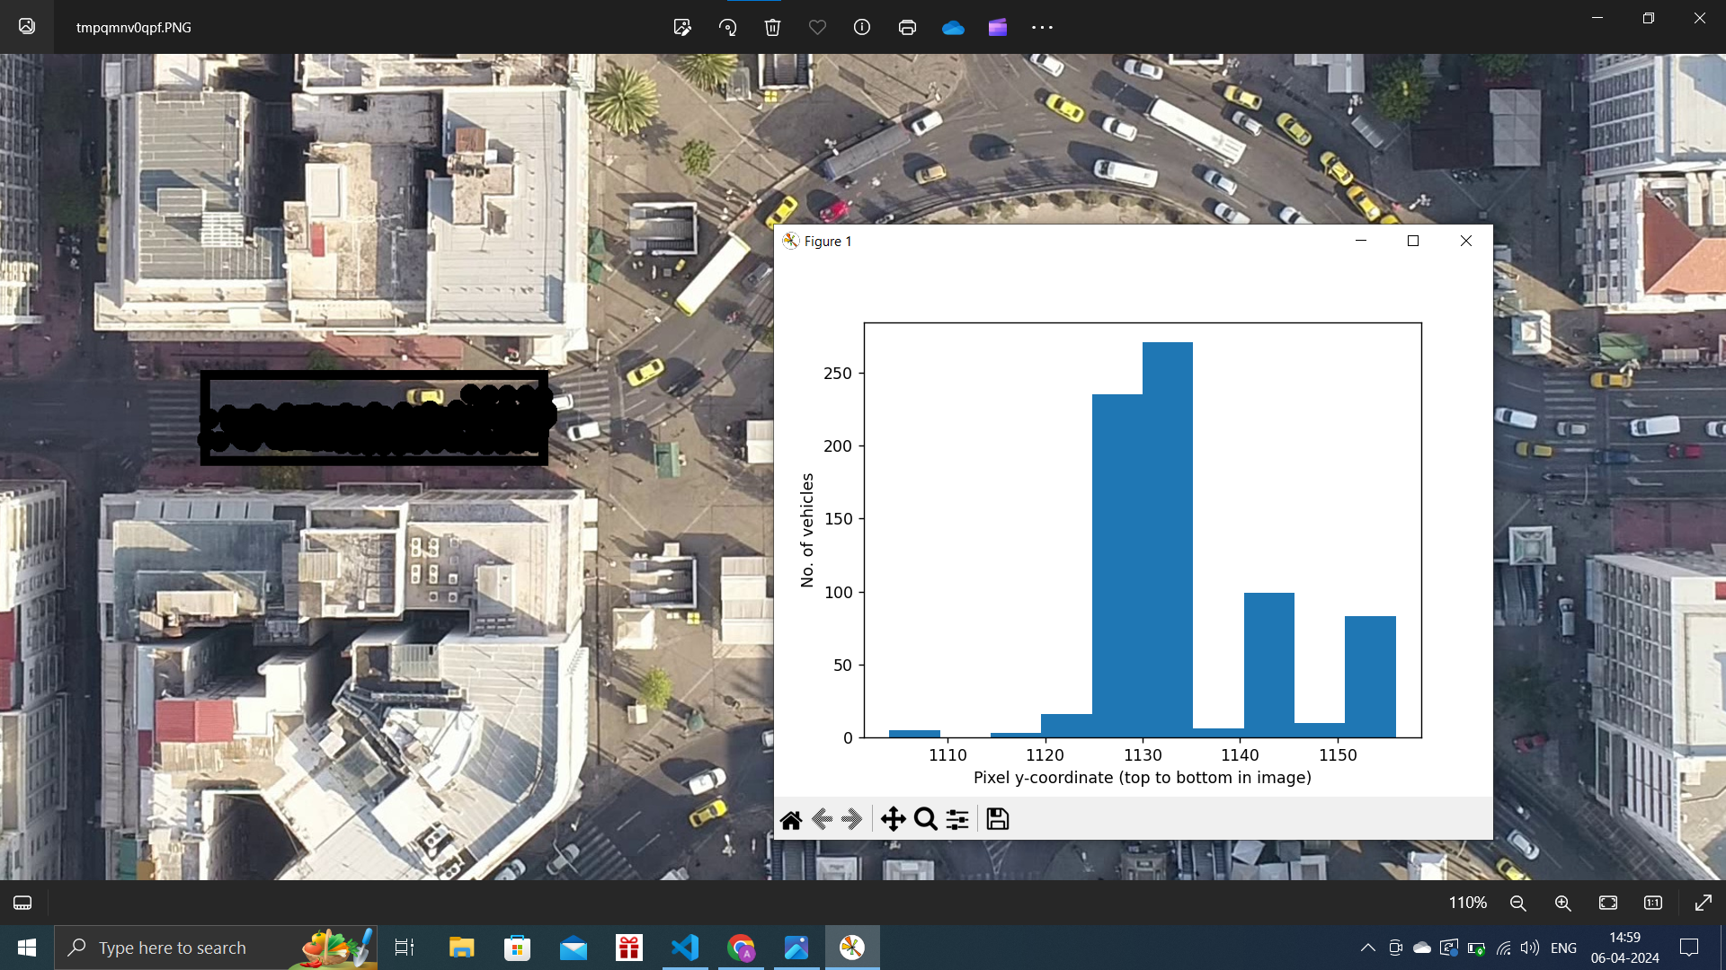

| Fig. 7. SubLoc 2 Start Time 106 Duration 100 Frames Filtered Motorcycle | Fig. 8. SubLoc 2 Start Time 106 Duration 100 Frames Filtered Motorcycle, Taxi |
| --- | --- |

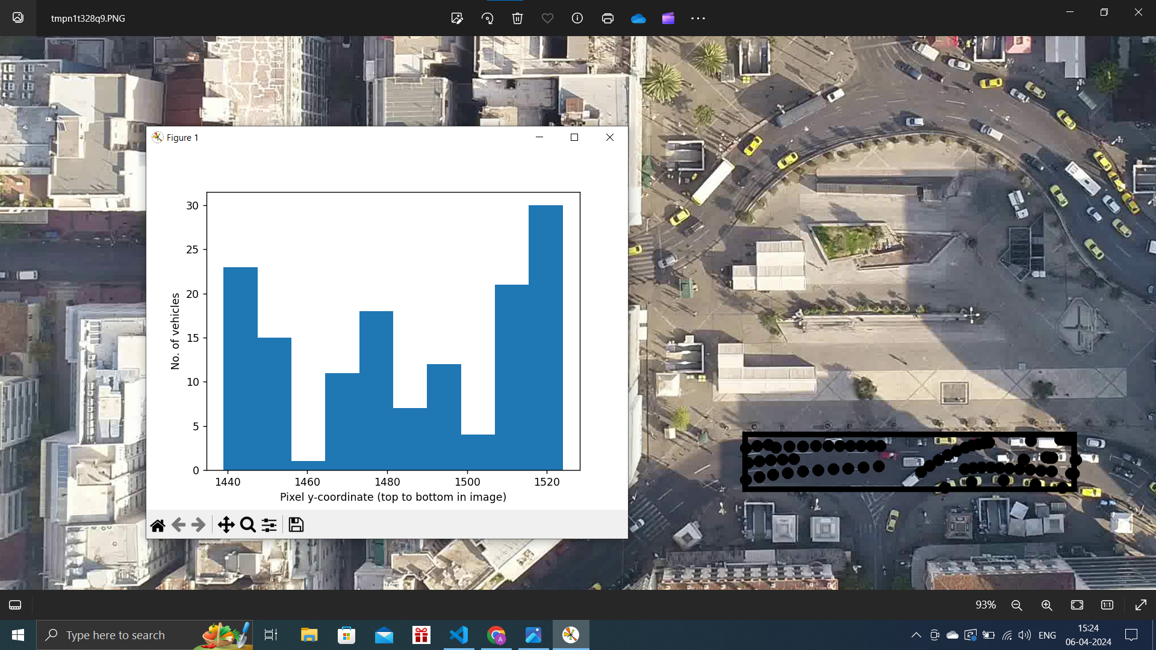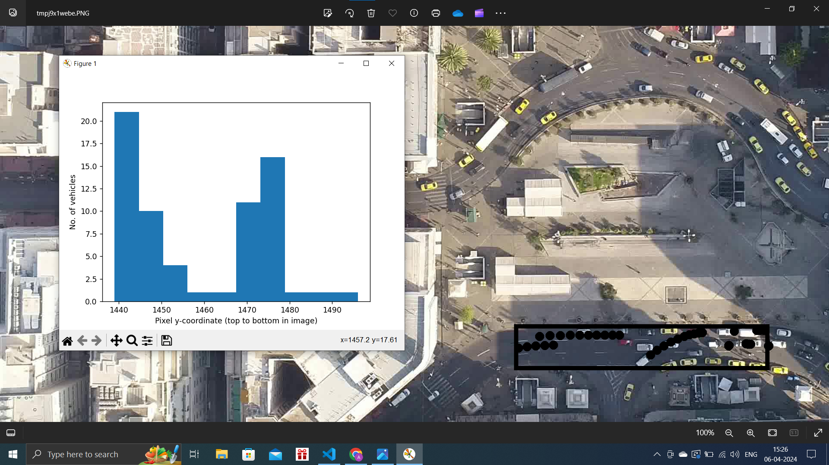

| Fig. 9. SubLoc 3 Start Time 86 Duration 10 Frames Filtered Motorcycle | Fig. 10. SubLoc 3 Start Time 86 Duration 10 Frames Filtered Motorcycle, Taxi |
| --- | --- |

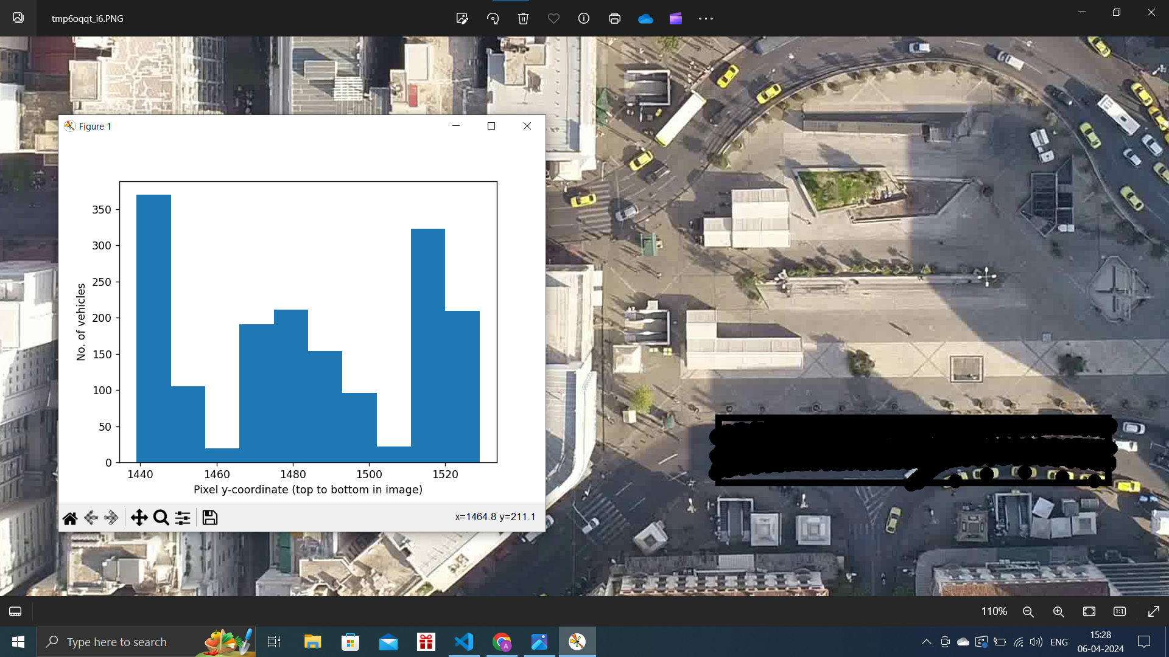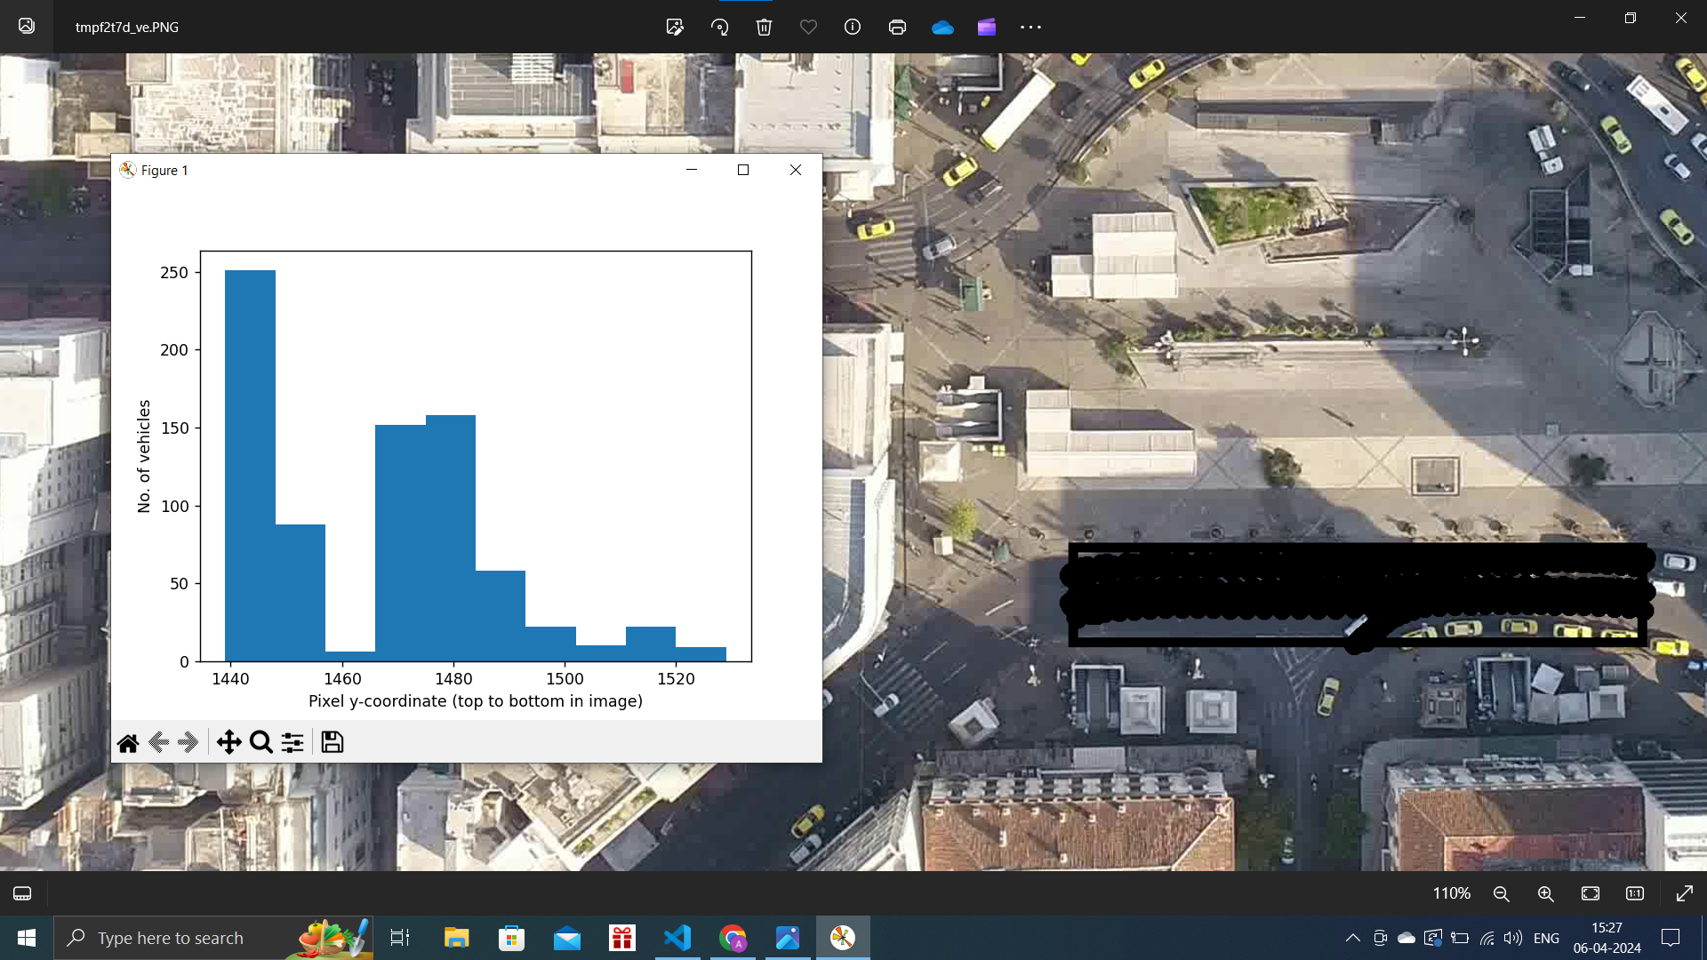

| Fig. 11. SubLoc 3 Start Time 86 Duration 100 Frames Filtered Motorcycle | Fig. 12. SubLoc 3 Start Time 86 Duration 100 Frames Filtered Motorcycle, Taxi |
| --- | --- |